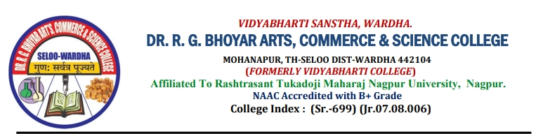

|  |  |
| --- | --- |
| **Activity Report** | |
| Academic Year | **2022-2023** |
| Name of Activity | **One day National Workshop on “Fundamentals on Intellectual Property Rights (IPR) ”** |
| Date of Activity | **25th February 2023** |
| Organized by | Internal Quality assurance cell (IQAC) of Vidyabharti College, Seloo |
| Organizing unit/ agency/ collaborating agency | Under the MoU of COTI |
| Number of students | 280 |
| Brief report | **Report on**  **One day National Workshop on “Fundamentals on Intellectual Property Rights (IPR)”**  One Day National workshop on “Fundamentals on Intellectual Property Rights (IPR)” was organized by Research cell of Internal Quality assurance cell (IQAC) under the MoU of COTI on **25th February 2023.**  In the inaugural program,  **Dr. Vishal N. Patil**, Convener of the program Dr. R.G. Bhoyar Arts, Commerce and Science College Seloo have given the introductory speech and to convey the importance of IPR.  As soon as the inaugural ceremony was ended at 11.10AM, the technical session was started. **Dr. Vaibhao Pimple** Asst. Professor Department of English was introduced the expert and handing over.  The **Technical Session** was delivered by **Dr. Mangala Hirwade,** Department of Library Science, RTM Nagpur University, Nagpur India.  She enlightened the participants on the history of Intellectual Property Rights. Her presentation began with explaining the various aspects of copy right and ‘what is patent’. How to file patents and its fee structure. She discussed in detail about the research, What do we mean by author or creator?’ Originality of Literary works, whom & how to apply for copyright and Online Copyright Registration process etc. IPR provides the formal framework for protecting their knowledge, creativity & innovation. She concluded the session by discussing about Trademark”, “Service Mark and Collective mark. His presentation was very much helpful to all participants. The session was ended at 12.35PM.  **Chairperson** of this workshop **Dr. Ashish Sasankar** Principal, Indraprastha Arts & Science College Wardhagiven the concluding excellent remark on workshop.  **Chairman** of this workshop **Dr. Sanjay Kanode,** Principal Dr. R.G. Bhoyar Arts, Commerce and Science College Seloo was given the concluding remark on workshop and also thanks to guests and all the delegates.  Dr. Wasim Khan did the very good anchoring of all the session and at the end Dr. Siddharth Nagdive given the vote of thanks and the national workshop ends with the prime permission of chairperson.  There were 280 enthusiastic participants in all including students and staff members who participated in the workshop.  The Workshop was highly informative to teachers, Research Scholars and students. As it is beneficial to all of us, teachers and students from other Colleges and departments were also participated. In short, the workshop provided valuable awareness and Insight on the various aspects of understanding Intellectual Property. |



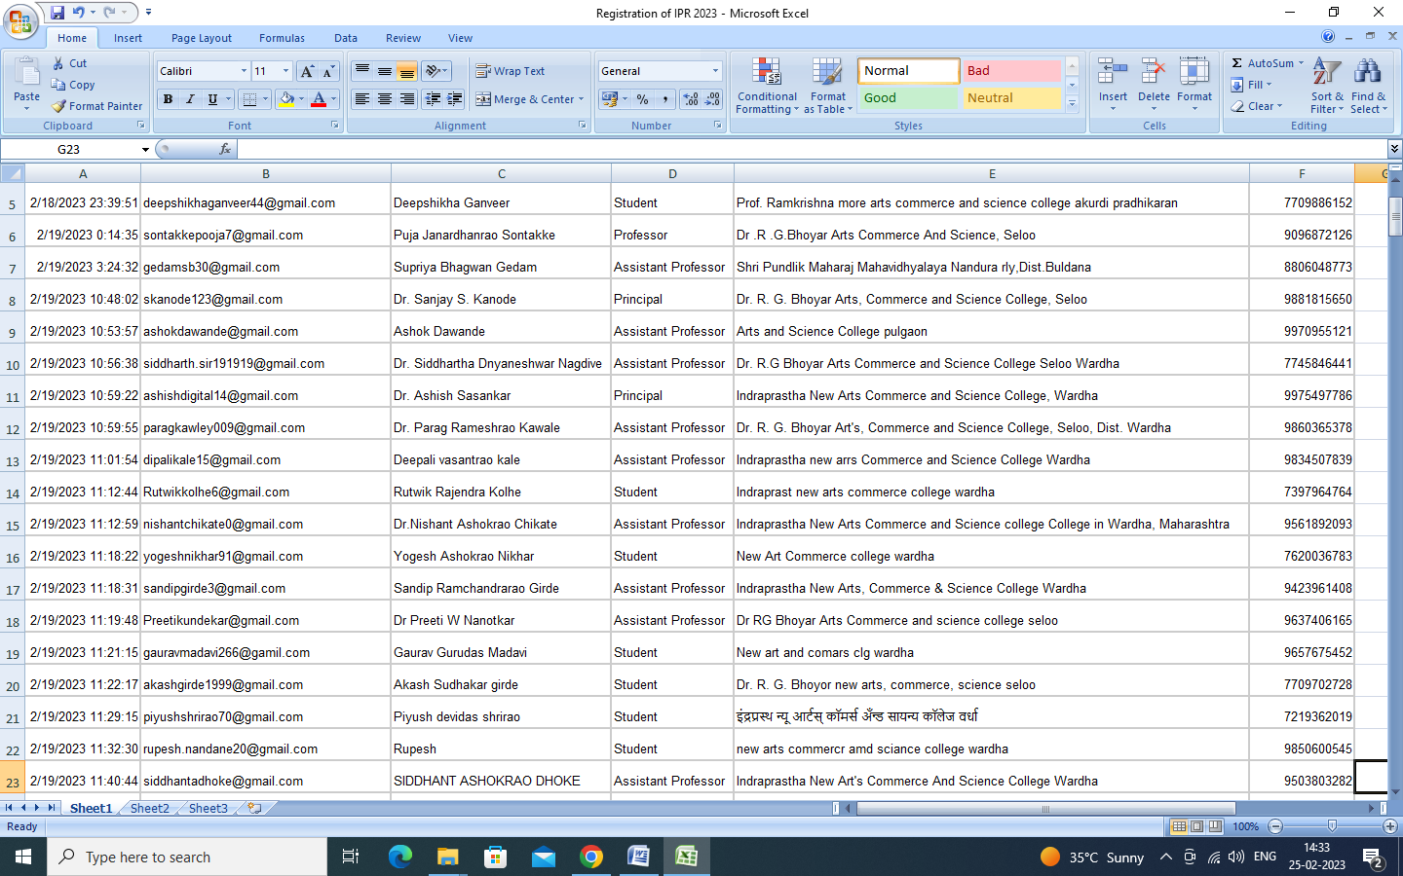

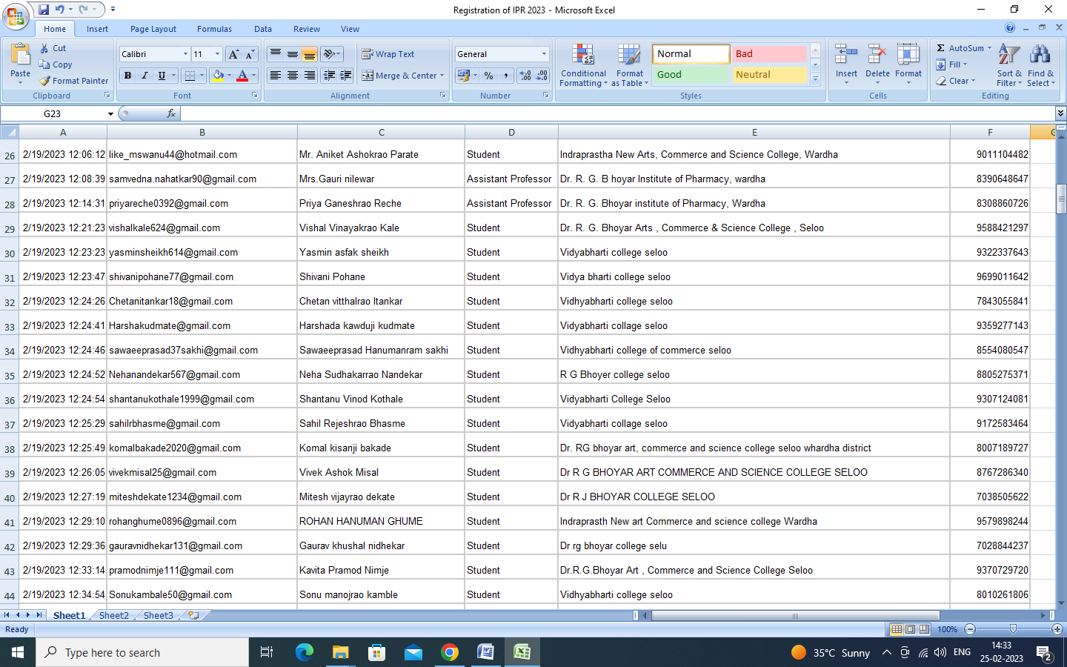

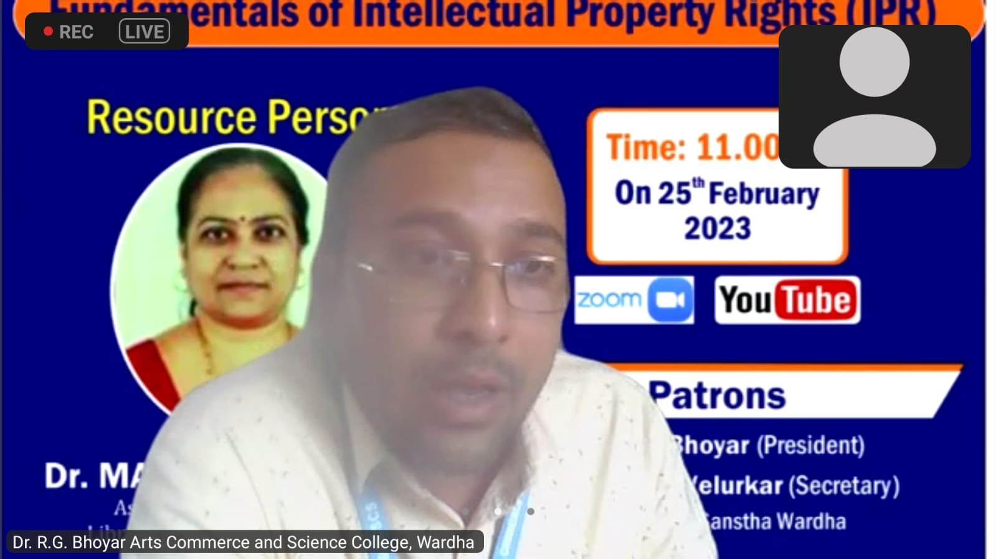

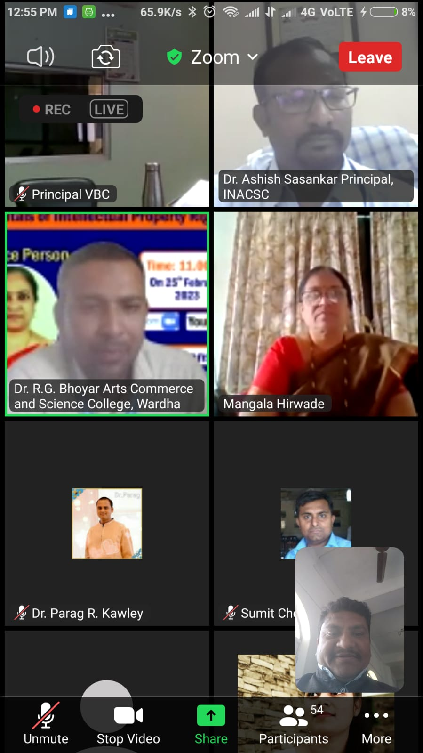 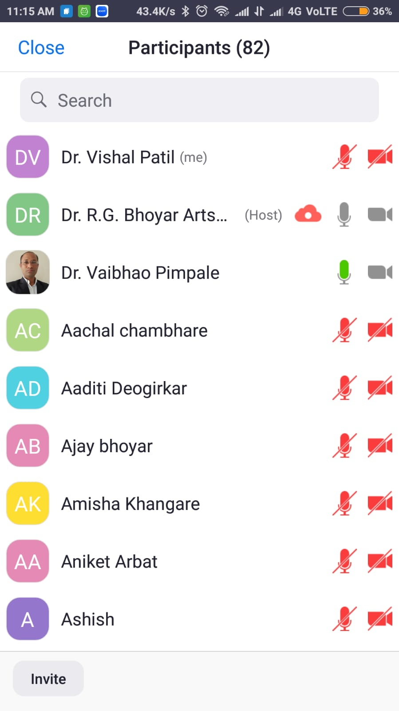

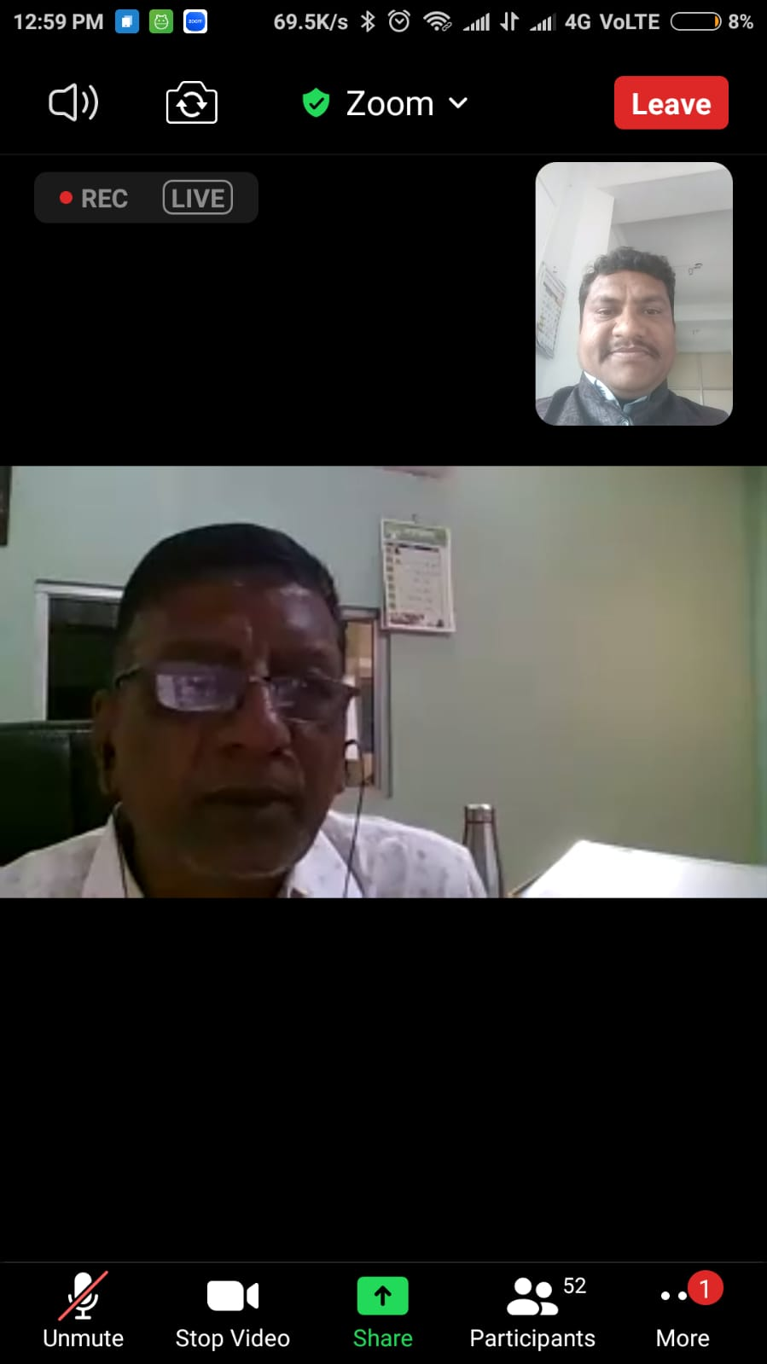 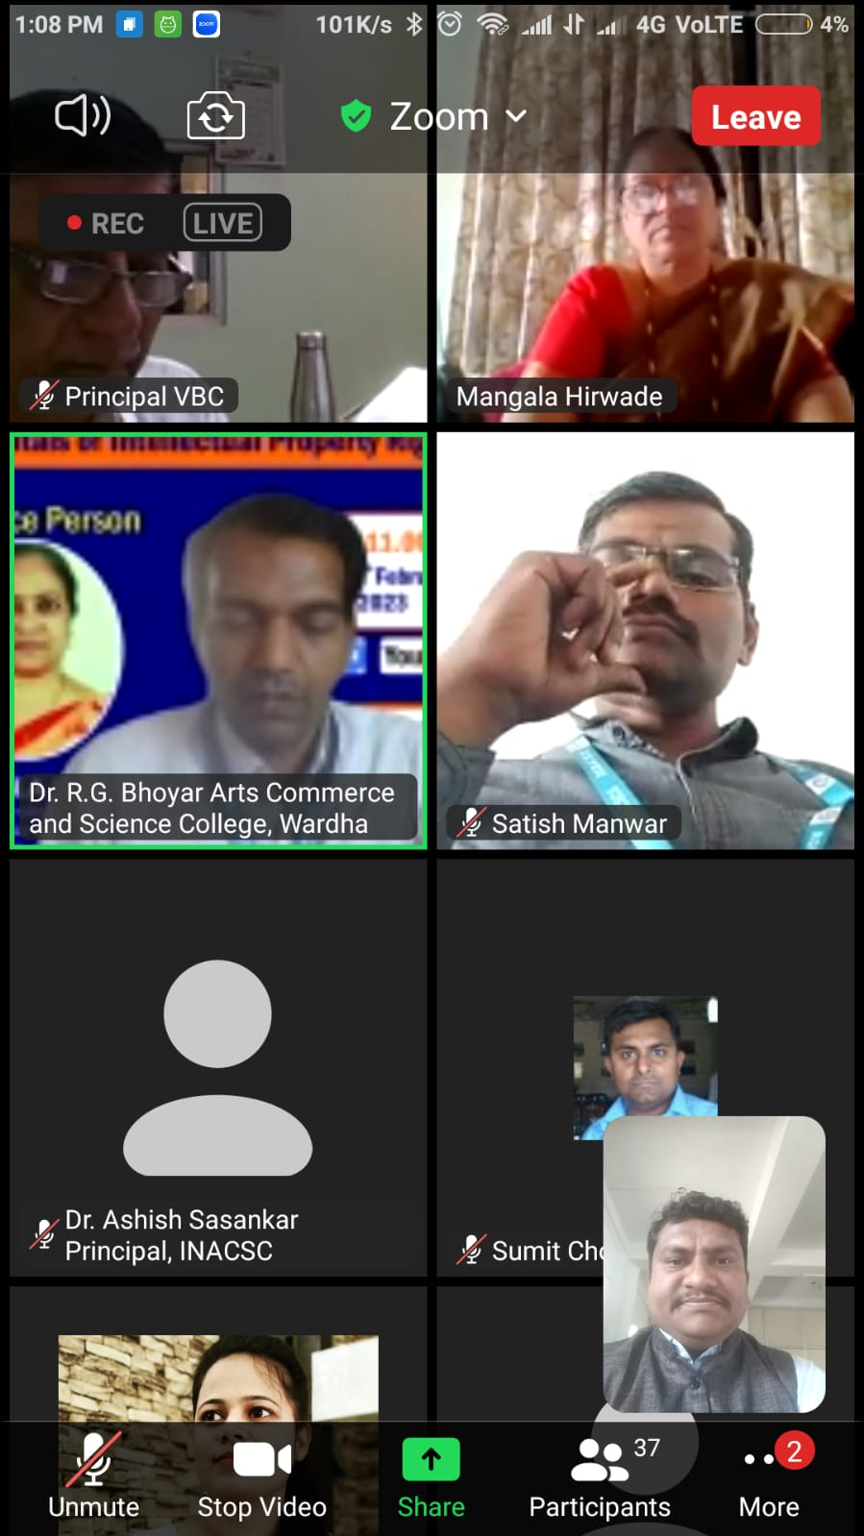

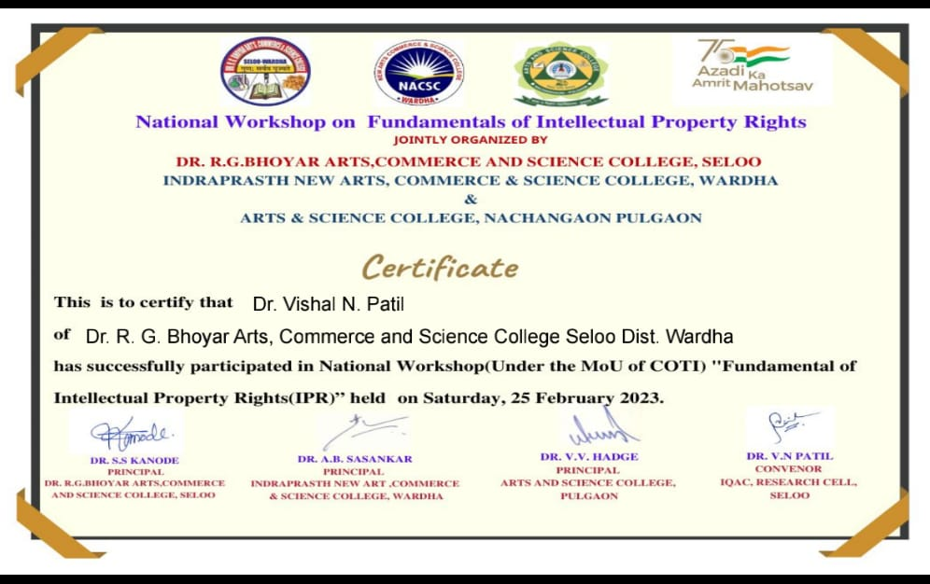

Zoom Link:

Dr. R.G. Bhoyar Arts Commerce and Science College, Seloo is inviting you to a scheduled Zoom meeting.

Topic: National Workshop on Fundamentals of Intellectual Property Rights (IPR)

Time: Feb 25, 2023 10:50 AM India

Join Zoom Meeting

<https://us06web.zoom.us/j/87219028860?pwd=dDlHQ29pdGlwa0kwV21zVnZpSlBCZz09>

Meeting ID: 872 1902 8860

Passcode: 689194

One tap mobile

+15642172000,,87219028860#,,,,*689194# US

+16469313860,,87219028860#,,,,*689194# US

Meeting ID: 872 1902 8860

Passcode: 689194

Find your local number: <https://us06web.zoom.us/u/kbV0pDUt3a>

Youtube link:

<https://www.youtube.com/live/A7bKYdnDhiQ?feature=share>

Feedback link:

<https://docs.google.com/forms/d/e/1FAIpQLSfuE4q_cJRaLJi7wgi8YL7TTTC5VPTXxQMYLss4JTyFlCS7Mw/viewform?usp=sf_link>

Date: 25.02.2023 Convener

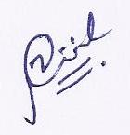

Dr. Vishal N. Patil

Research Cell Committee